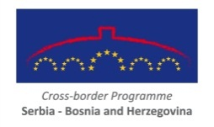
This programme is funded by the EU

Info Days schedule for Cross-border Programme Serbia - BiH

As a part of the 3rd CfP activities for the Cross-border Programme Serbia – BiH 2007-2013 Info days will be organised according to following schedule

Date | Time | City | Address | Agenda
29. 4. 2015 | 13:00-16:30 | Belgrade SRB | Dom omladine Beograda, Makedonska 22/IV | Agenda - Belgrade
30. 4. 2015 | 10:30-14:00 | Valjevo SRB | Sala skupštine grada Valjeva, Karađorđeva 64 | Agenda - Valjevo
5. 5. 2015 | 11:00-14:30 | Srebrenica BiH | Kulturni centar, Srebreničkog odreda bb | Agenda - Srebrenica
8. 5. 2015 | 10:30-14:00 | Šabac SRB | Hotel Sloboda, Trg Šabačkih žrtava bb | Agenda - Šabac
12. 5. 2015 | 11:00-14:30 | Brčko Distrikt BiH | Grand hotel Posavina, Trg Mladih 4 | Agenda -Brčko Distrikt

In order to apply, please fill the form from programme web site by choosing only one location and send it to e-mail imarkovic@seio.gov.rs

Registration Form can be found here

